# Formula One

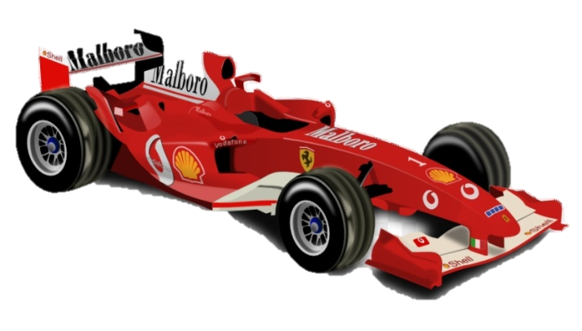

You will be given an integer N for the size of the square matrix and then an integer for the count of commands. On the next **n** lines, you will receive the rows of the matrix. The player starts at a random position (the player is marked with **"P"**) and **all of the empty slots** will be filled with **"." (dot)**. The goal is to reach the finish mark which will be marked with **"F"**. On the field there can also be bonuses and traps. Bonuses are marked with **"B"** and traps are marked with **"T"**.

Each turn you will be given commands for **the player’s movement.** If the player **goes** **out** of the matrix, he comes in from **the other side**. For example, if the player is on 0, 0 and the next command is left, he goes to the last spot on the first row.

If the player steps on a **bonus**, he should move another step forward in the direction he is going. If the player steps on a **trap**, he should move a step backwards.

When the player reaches the **finish mark** or the **count of commands is reached,** the game ends.

### Input

* On the first line, you are given the integer N – the size of the square matrix.
* On the second you are given the count of commands.
* The next N lines hold the values for every row.
* On each of the next lines you will get commands for movement directions.

### Output

* If the player reaches the finish mark, print:
  + **"Well done, the player won first place!"**
* If the player reaches the commands count and hasn’t reached the finish mark print:
  + **"Oh no, the player got lost on the track!"**
* In the end print the matrix.

### Constraints

* The size of the matrix will be between **[2…20].**
* The players will always be indicated with **"P".**
* If the player steps on the finish mark **at the same time** as his last command, he **wins** the game.
* When the final matrix is printed and the vehicle has completed successfully, you must replace the "F" with the "P".
* Commands will be in the format **up**, **down**, **left** or **right**.
* There won't be a case where you bypass the finish while you are on a trap or a bonus.
* A trap will never place you into a bonus or another trap and a bonus will never place you into a trap or another bonus.

### Examples

|  |  |  |
| --- | --- | --- |
| **Input** | **Output** | **Comments** |
| 5  3  .....  .P...  .B...  ..T..  .F...  down  right  down | Well done, the player won first place!  .....  .....  .B...  ..T..  .P... | The first command is **down** so **P** moves down. On turn 1, the player steps on a bonus and does an additional step. On turn 2, the player steps on a trap and goes a step back. After each turn the field is:  1 2 3  ..... ..... .....  ..... ..... .....  .B... .B... .B...  .PT.. .PT.. ..T..  .F... .F... .P...  On turn 3 **P** reaches the finish 'F' and wins the game. |
| 4  3  ....  .P.B  ..T.  ...F  up  up  left | Oh no, the player got lost on the track!  ....  ...B  ..T.  P..F | The first command is **up** so **P** moves up and the new player position is **(0,1).** The next command is **up** again, so the player goes **out** **of the matrix** and **comes back from the other side at (3,1).** Then the command is **left**, so the end position is **(3,0)** which is not the finish mark, so the **player has lost**. |